Design of an Intelligent Bracelet Based On IOT and LORA Protocol to Identify New COVID-19 Contact Cases
Alternate Title: An Active Mechanism to Discover Omicron cases
Objective:
Our main function is to create a wireless network to notify the patient with omicron and alert the public around the newly identified patient’s location.
Abstract:
COVID-19 has rapidly spread globally, and it was officially declared to be a pandemic by the World Health Organization. Most countries over the entire globe have reported thousands of COVID-19 cases and many of them lost their lives.
These mutations create new variants of the virus. Sometimes the variants are less contagious have slightly different presenting symptoms. Unfortunately, the delta variant of COVID-19 is more highly contagious and more likely to result in severe illness.
Like other variants, omicron spreads from the nose and mouth through respiratory droplets at close range and through virus particles that float through the air and can stay suspended for quite awhile, especially in places with poor environment.
In our device, patient’s health data is taken through Heart rate and SPO2 sensor, LM35 is transmitted to cloud through ESP32. The data and COVID-19 test reports were analyzed by doctors if results are positive a warning signal is transmitted from hospital to patient’s device. The patient’s device has an RGB led which is used as a signal to alert the patient. If the doctor didn’t get the acknowledgement from the patient, LORA network is used to get the location of the patient.

Existing System:
This existing system does online monitoring, early diagnosis, and treatment assistance for covid-19 in terms of social distancing and quarantine. And it is based on wireless healthcare networks, the internet of things and cloud computing.
Proposed System:
Our proposed system is to create a network that ensures the notification and location of omicron positive patients and alert the public’s around the patient’s location. And monitor the patient’s health in real time.
Block Diagram:
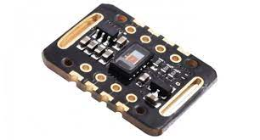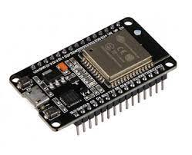
LORA
ESP32
LM35
Heart Rate and SPO2 Sensor
LORA
Node MCU
Cloud Database
Doctor’s Computer
Hardware Requirements:
- Node MCU
- ESP32
- LORA-2
- LM35
- Heart Rate and SPO2 Sensor
- Android Mobile(student’s mobile)
Software Requirements:
- Arduino IDE
- Android Studio

